**Lab 4: Diode Applications**

**Keegan** **Smith**

**Bench** 19

**Electronics** 1 Lab

**EECE.3110 P 1 804A**

**Date submitte**d 03/21/2022

**Due date** 03/27/2022

1. **SUMMARY**

This document reports my findings as well as the construction and analysis of multiple diode application circuits. These circuits include the half-wave rectifier, full-wave rectifier, bridge rectifier, diode clipping circuit, diode clamping circuit, and a real-time clock battery back-up circuit. In many of these circuits’ diodes are used to cut off, or clip, part of an AC input signal. Some of them, such as the real-time clock battery back-up circuit uses diodes to protect two different voltage sources from each other.

1. **EQUIPMENT**

|  |  |  |
| --- | --- | --- |
| **Equipment Type** | **Details** | |
| * Oscilloscope | *Make:* | InfiniiVision |
| *Model:* | DSO-X2004A |
| *Serial Number:* | MY52161432 |
| * Digital Multimeter | *Make:* | Keithley |
| *Model:* | 2110 5½ |
| *Serial Number:* | 8004026 |
| * DC Power Supply | *Make:* | GWInstek |
| *Model:* | GPD-3303D |
| *Serial Number:* | EM840514 |
| * Function Generator | *Make:* | Tektronix |
| *Model:* | AFG1022 |
| *Serial Number:* | AFG102217331728 |
| * Analog Discovery | *Make:* | Digilent |
| *Model:* | Analog Discovery 2 |
| *Serial Number:* | 210231B0DF82 |
| * Breadboard * Bench “Shoebox” with connector cables, adapters, clips etc. | N/A | |

**Table 1. Equipment**

**Table 2. Components**

|  |  |  |
| --- | --- | --- |
| **Component Type** | **Quantity** | **Details** |
| Resistor | 1 | 100Ω |
| Resistor | 1 | 470Ω |
| Resistor | 2 | 1kΩ |
| Resistor | 2 | 2.2kΩ |
| Resistor | 3 | 10kΩ |
| Resistor | 1 | 100kΩ |
| Capacitor | 1 | 100µF |
| Capacitor | 1 | 1000µF |
| Signal Diode | 1 | 1N914 |
| Rectifier Diode | 4 | 1N4001 |

1. **INTRODUCTION**

Diodes are made by putting p-region and n-region of semiconductor materials together, creating a PN junction. Between these the P and N region lies the depletion region. The half of the depletion region close to the N-region is positively charged, and the half next to the P-region is negatively charged. When a voltage more than 0.7v (for silicon diodes) is applied to the P-region of the diode (the anode), the depletion region breaks down and allows current to flow through the semiconductor. However, when a voltage is applied to the N-region (the cathode), the depletion region stays intact and does not allow current to flow through the device. Even though this is a simple function, the diode is an extremely important device in ESD protection, voltage regulation, rectifying and more.

A half-wave rectifier circuit takes advantage of the diode to remove half of an input signal, or AC current source. Due to the diode not allowing current through the cathode, only positive voltage can continue to the rest of the circuit. This works because when a negative voltage is applied the diode will short the voltage source from the load.

The full-wave rectifier works just like the half-wave, but it employs another diode. If one connects a voltage source to both diodes, there will be no voltage that travels to the load circuit. However, if two sources are used, there are two half-wave rectifiers summing into a single node to the load circuit.

A bridge rectifier, sometimes called a full-wave bridge rectifier, uses four diodes in a H pattern configuration. As a positive voltage is applied, the current travels through one diode, across the load resistor or circuit, through another diode, and then to ground. When the negative voltage from an alternative current comes up from ground, it does the same as before, but from the bottom to the top of the rectifier circuit. This circuit is special because it only supplies positive voltage to the load circuit. The output can also be filtered with a very large capacitor to further smooth out the AC to DC currents.

The diode clipping circuit “cuts” or “clips” part of an input signal. If the diode is forward biased from the positive part of the circuit, it will clip the positive voltage from the load and hold it at 0.7v, the diodes turn on voltage.

If one were to take the diode clipping circuit and flip the diode around so it was reverse biased from the positive part of a circuit, it would become a diode clamping circuit. This circuit shorts the negative voltage out clamping the output to the inputs positive current.

The real-time clock battery back-up circuit works by having two diodes forward biased from two separate DC supplies. When the main voltage source is applied, 5v will join the 3v battery and power the circuit. Due to the diode, the 5v will not touch the battery. When the main voltage is off, 3v powers the clock circuit and the diode in front of the 5v supply prevents current from that part of the circuitry.

1. Diagram, schematic

   Description automatically generated**CIRCUIT DESCRIPTION**

**Figure 10. Half-Wave Rectifier with Filter Capacitor**

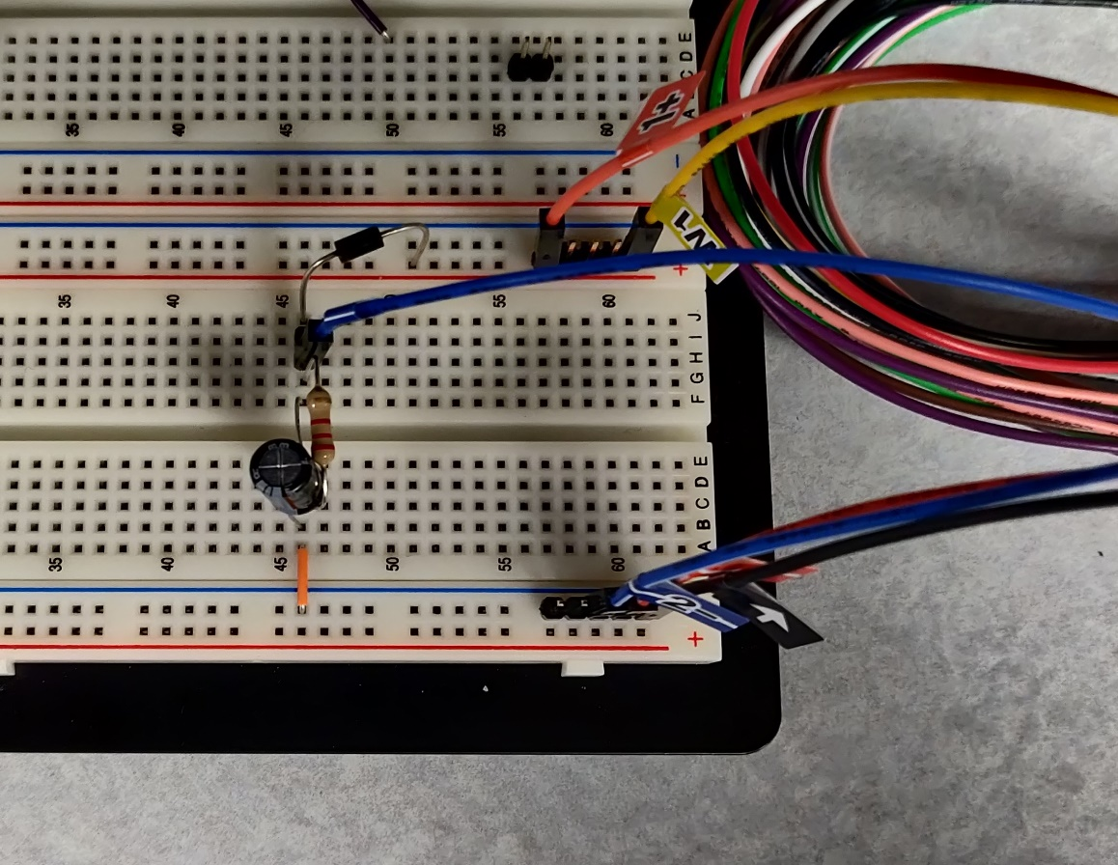

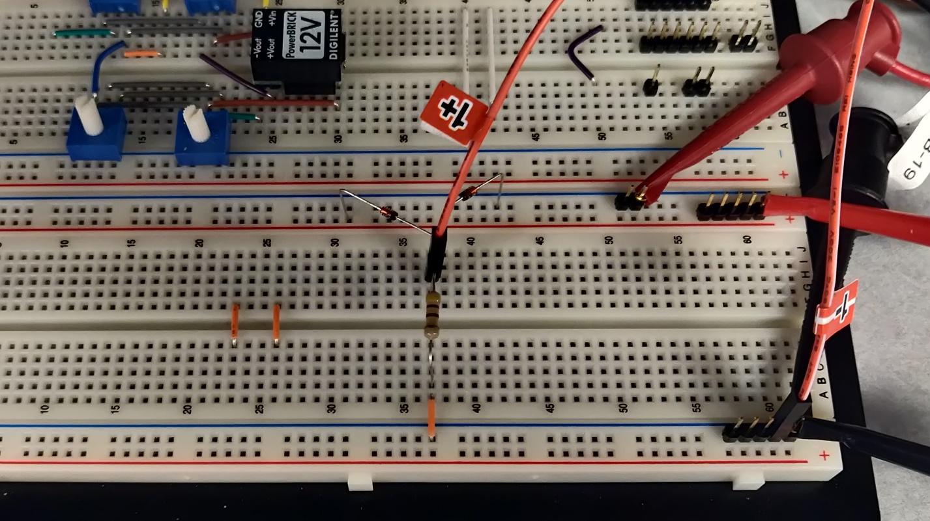**Figure 11. Full-Wave Rectifier without Filter Capacitor**

**Figure 12. Full-Wave Rectifier with Two 2.2kΩ Load Resistors and 100µF Filter Capacitor**

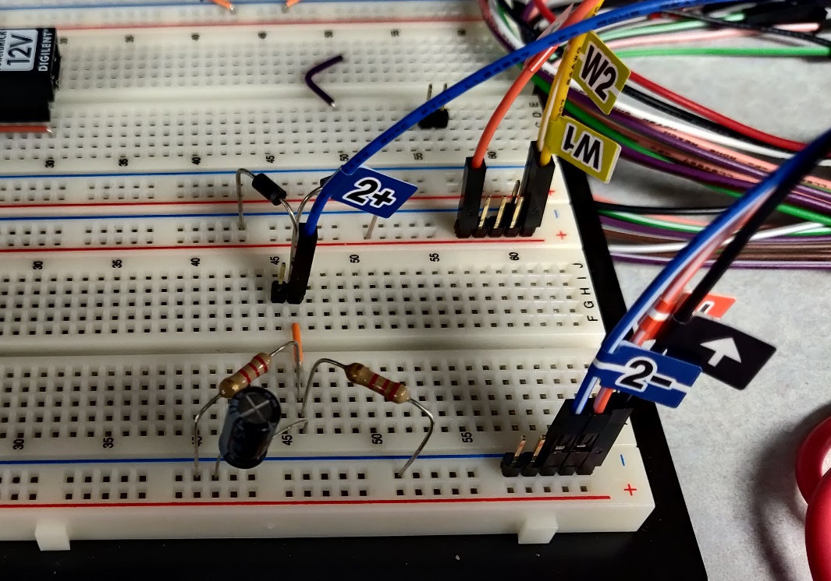

**Figure 13. Bridge Rectifier with 1000µF Filter Capacitor**

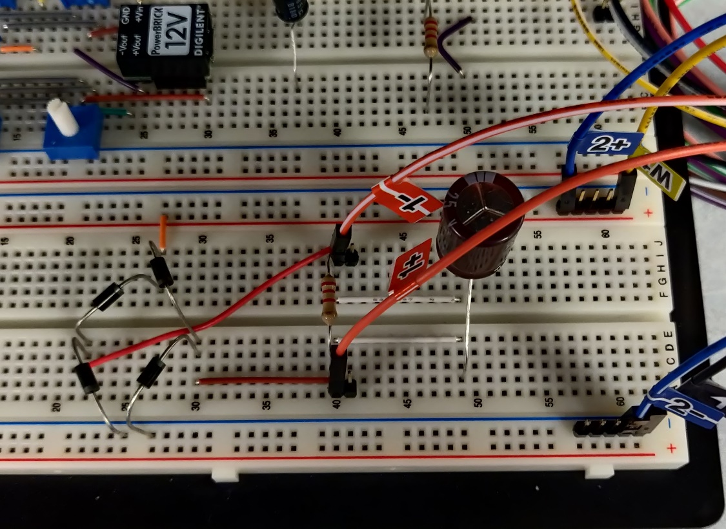

**Figure 14. Design Challenge: Positive Voltage**

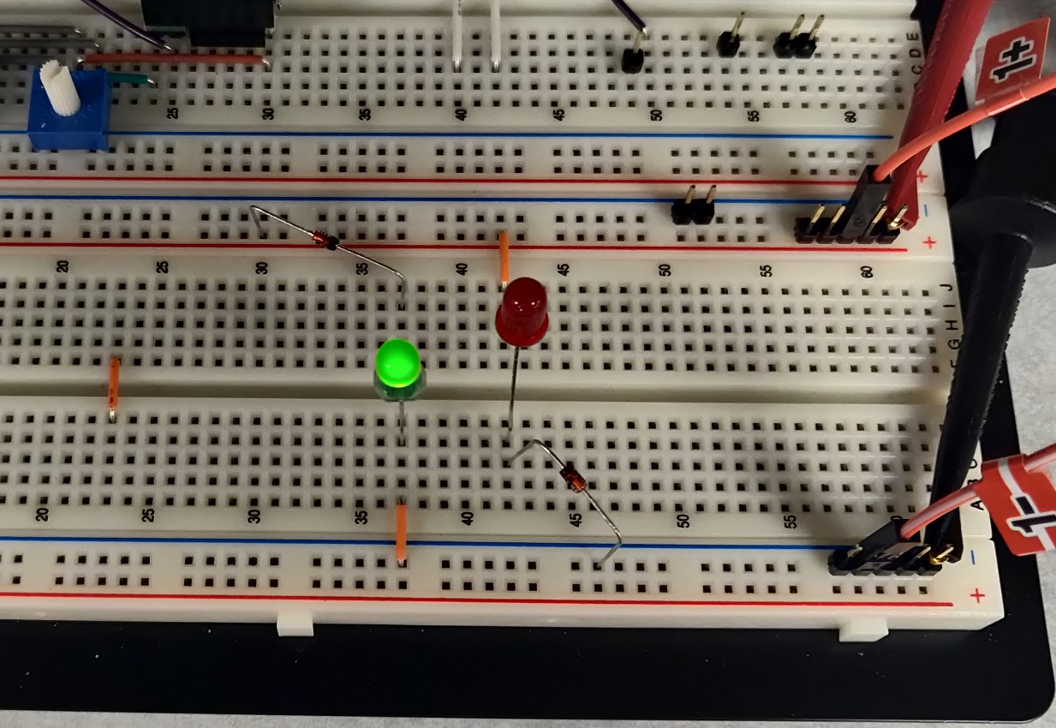

**Figure 15. Design Challenge: Negative Voltage**

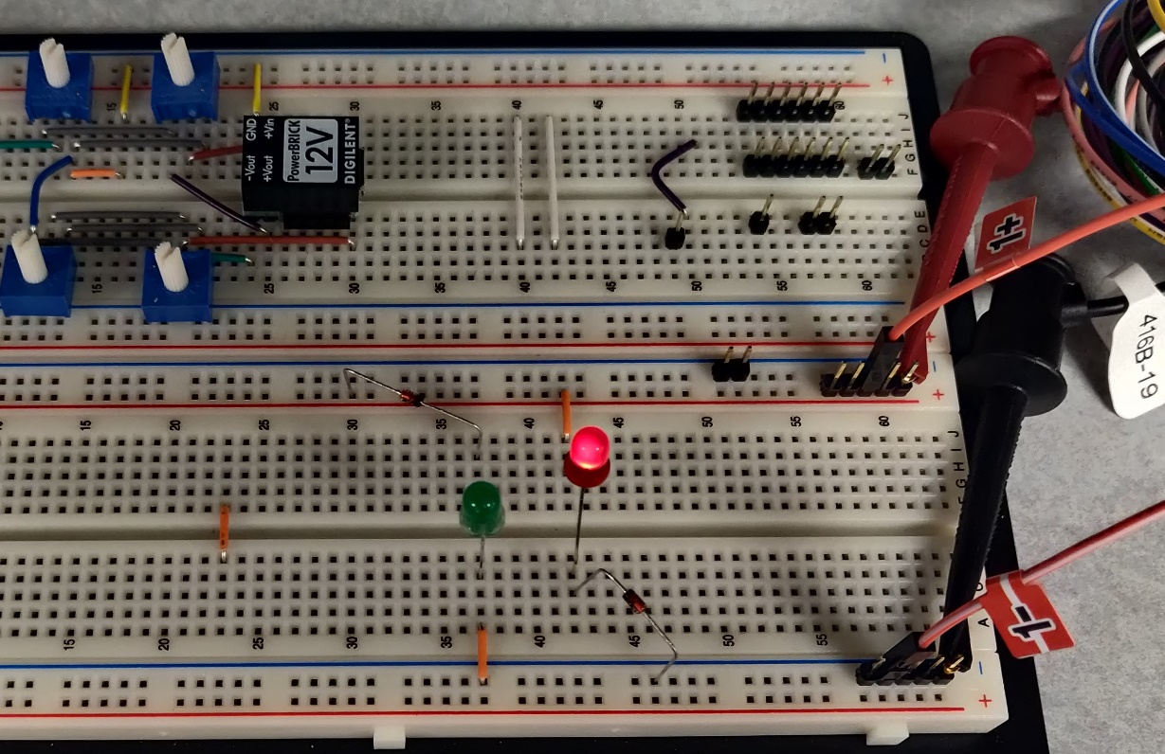

1. **MEASUREMENTS**

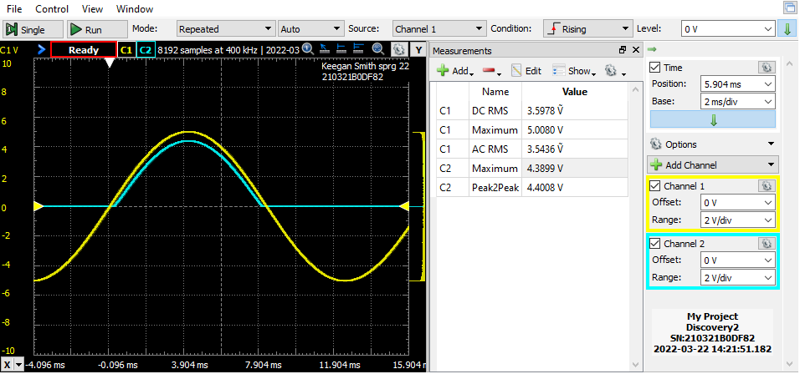**Figure 16. Half-Wave Rectifier without Filter Capacitor**

**Figure 17. Half-Wave Rectifier with Filter Capacitor**

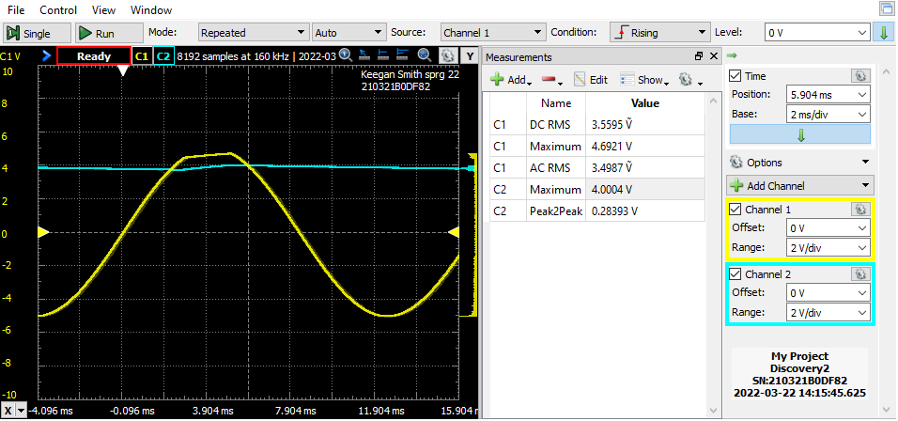

**Table 3. Half-Wave Rectifier Results**

|  |  |  |  |  |  |  |
| --- | --- | --- | --- | --- | --- | --- |
| **Without Filter Capacitor** | | | | **With Filter Capacitor** | | |
| **Computed** | **Measured** | **Computed** | **Measured** | **Measured** | | |
| VW1  (rms) | VW1  (rms) | VOut  (p) | VOut  (p) | VOut  (p) | VRL  (p-p) | Ripple Frequency |
| 7.07v | 3.541v | 4.67v | 4.3863v | 1.155v | 0.28757v | 59Hz |

Seen in figures 10 and 11 as well as table 3 are the results recorded in with the half-wave rectifier circuit.

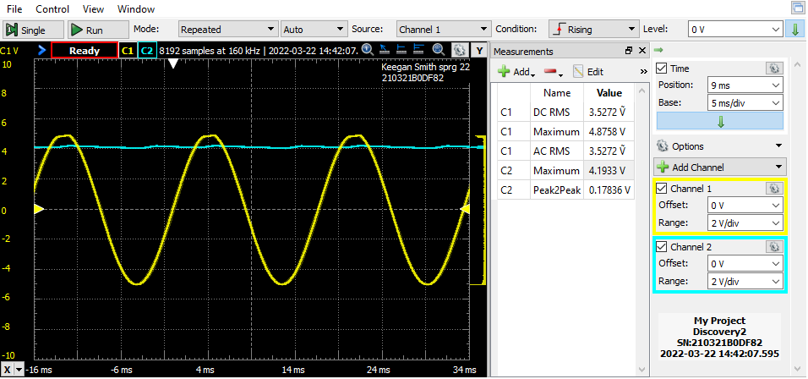**Figure 18. Full-Wave Rectifier with Filter Capacitor**

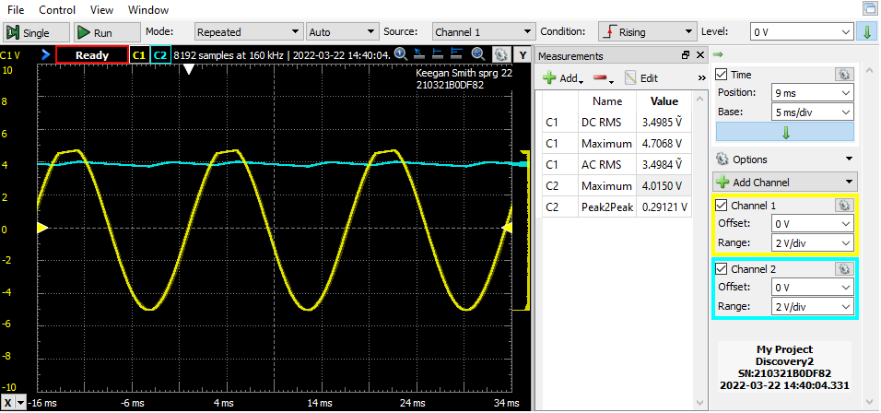**Figure 19. Full-Wave Rectifier with Filter Capacitor and Two 2.2kΩ Load Resistors in Parallel**

**Table 4. Full-Wave Rectifier Results**

|  |  |  |  |  |  |  |  |  |
| --- | --- | --- | --- | --- | --- | --- | --- | --- |
| **Without Filter Capacitor** | | | | | | **With Filter Capacitor** | | |
| **Computed** | **Measured** | **Computed** | **Measured** | **Computed** | **Measured** | **Measured** | | |
| VW1  (rms) | VW1  (rms) | VW2  (rms) | VW2  (rms) | VOut  (p) | VOut  (p) | VOut (p) | VRL  (p-p) | Ripple Frequency |
| 7.07v | 3.5405v | 3.53v | 3.55v | 4.675v | 4.6593v | 1.155v | 0.1674v | 30Hz |

Table 4 shows the results recorded from figures 12 and 13. The differences between these figures is that figure 13 has two load resistors in parallel, increasing the current draw of the load and making the ripple of the filter capacitor more apparent.

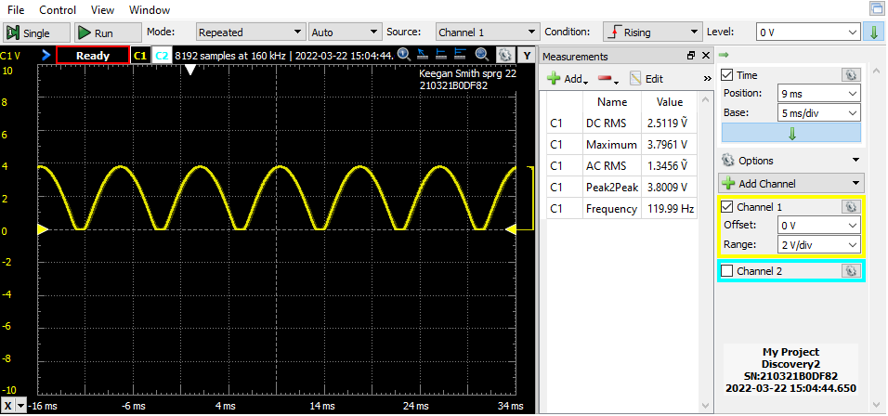**Figure 20. Bridge Rectifier without Filter Capacitor**

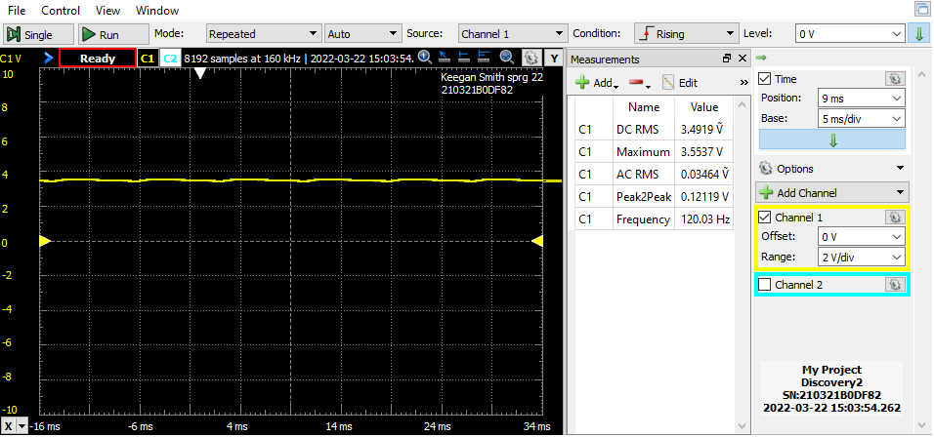**Figure 21. Bridge Rectifier with 100µF Filter Capacitor**

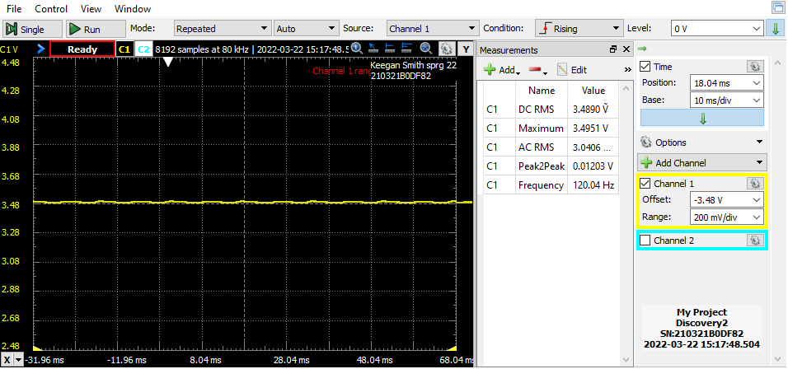**Figure 22. Bridge Rectifier with 1000µF Filter Capacitor**

**Table 5. Bridge Rectifier Results**

|  |  |  |  |  |  |  |  |
| --- | --- | --- | --- | --- | --- | --- | --- |
|  | **Without Filter Capacitor** | | | | **With Filter Capacitor** | | |
| **Computed** | **Measured** | **Computed** | **Measured** | **Measured** | | |
| 100µF  Filter  Cap | VW1  (rms) | VW1  (rms) | VOut  (p) | VOut  (p) | VOut  (p) | VRL  (p-p) | Ripple Frequency |
| 7.07v | 3.525v | 2.943v | 3.796v | 3.4959v | 0.12199v | 120Hz |
| 1000µF  Filter  Cap | N/A | N/A | N/A | N/A | 3.495v | 0.01836v | 120Hz |

Table 5 shows the numerical results of figures 14, 15 and 16.

**Figure 23. Diode Clipping Circuit with RL = 10kΩ\*\***

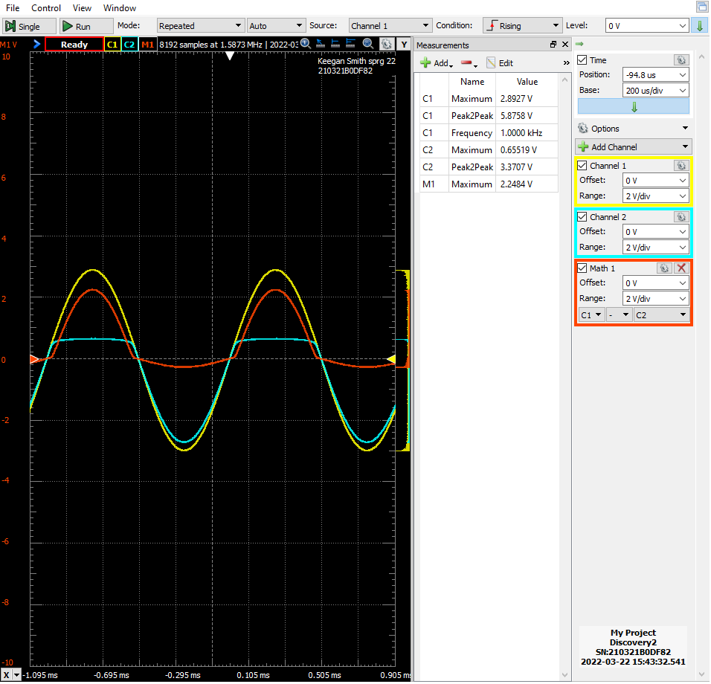

**Figure 24. Diode Clipping Circuit with RL = 100kΩ\*\***

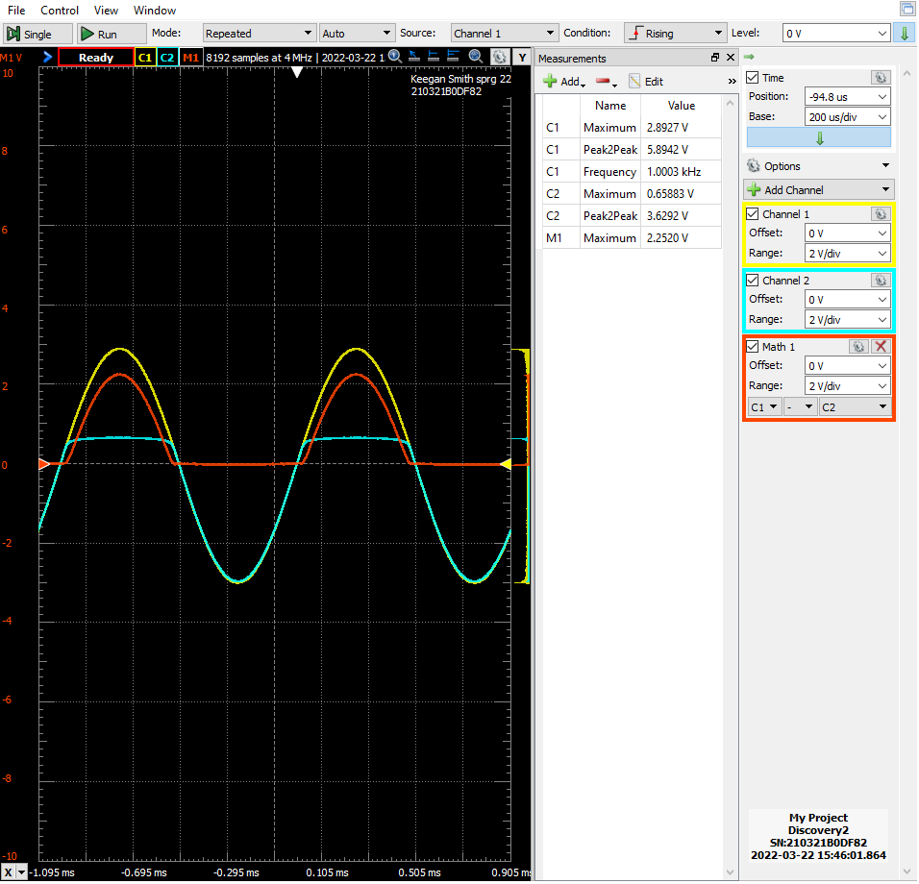

**Figure 25. Diode Clipping Circuit with RL = 100kΩ and 2V DC on Diode Cathode\*\***

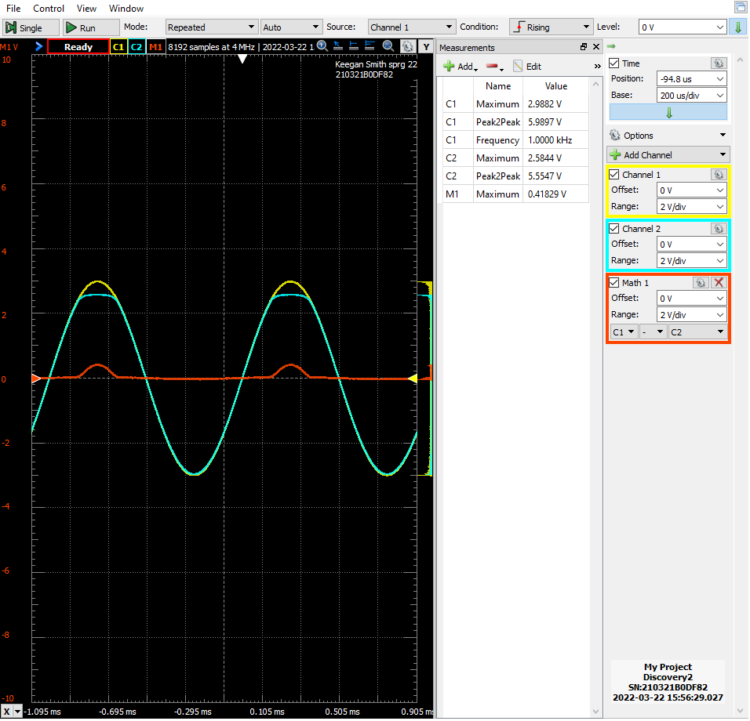

** Channel 1 is the input signal, channel 2 is the output, and math is the difference between channel 1 and channel 2 so, how much voltage was clipped.

**Figure 26. Diode Clamping Circuit, Part a**

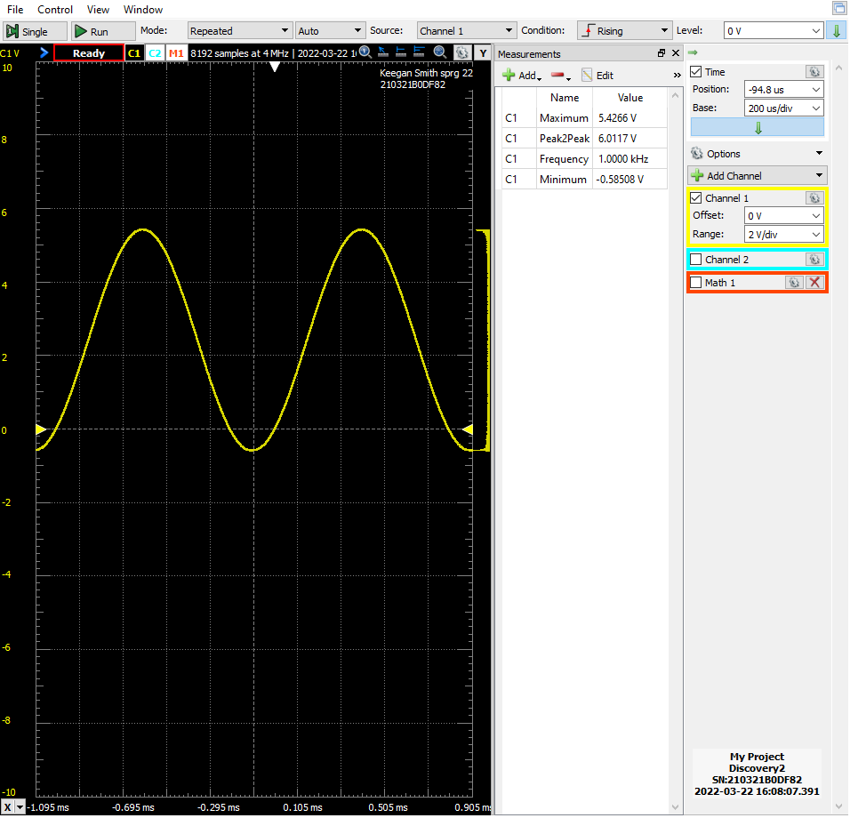

**Figure 27. Diode Clamping Circuit Part c**

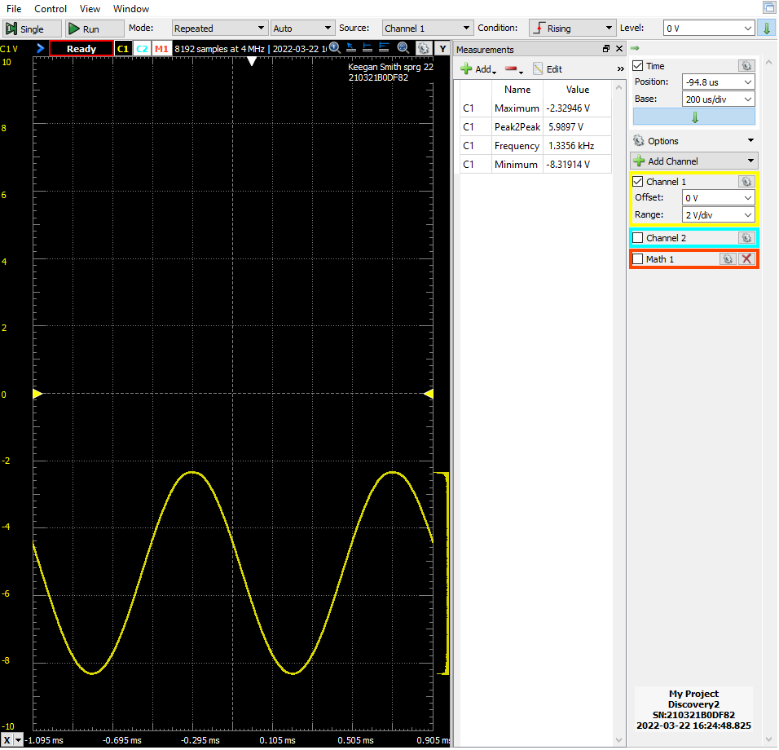

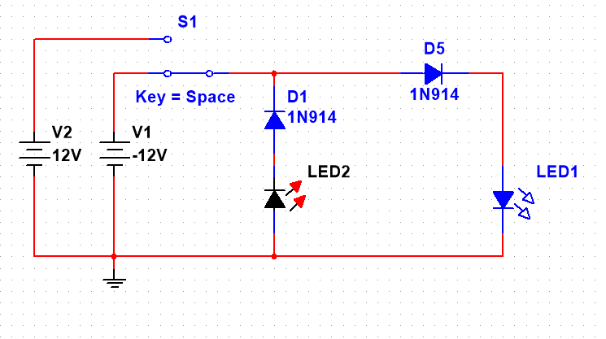**Figure 28. Design Challenge: AC/DC Polarity Indicator**

1. **DISCUSSION**

Section one of the laboratory procedure is constructing and analyzing a Half-Wave rectifier. This circuit uses a diode in forward-bias as to not allow the negative part of the input signal through. In figures 16 and 17 channel 1 is the input signal and channel 2 is the output of the circuit. Comparing the two figures you can see when adding a capacitor in parallel with the load resistor, the filter capacitor “fills” in the output wave when the diode is turned off and smooths out the wave. Because the capacitor needs to charge, a small dip, or pulsing, in voltage is seen as the capacitor charges and discharges.

Looking at table 4 we see the values recorded from section two, the full-wave rectifier circuit. In this section a full-wave rectifier was constructed, and the oscilloscope images saved. Looking at figures 18 and 19, we see what it the output looks like when there is a filter capacitor in parallel with the load resistor. However, in figure 19 we see the ripple is far more noticeable than in figure 18. This happens because there are two load resistors in parallel with the filter capacitor, drawing more current, making a steeper discharge curve.

Section three is about the operation and visualization of the bridge rectifier. This rectifier circuit uses four diodes in a certain configuration and a resistor connected in between two points. This configuration flips the negative portion of the input signal because the voltage goes through the load the same direction regardless of the input. Therefore, the output look like figure 20. When a filter capacitor is place in parallel with the load resistor, it has the same effect as the other circuits, smoothing out the output. However, due to all components of the signal being positive, the ripple from the capacitor is smoother. During part f of the section, the 100µF capacitor is replace with a 1000µF one, smoothing it out further.

In section four a diode clipping circuit is built and analyzed. A diode clipping circuit works like the half-wave rectifier except that the diode is in parallel with the load, instead of series. In this circuit, when the input signal is in forward-bias of the diode, it clips the load voltage to the turn on voltage of the diode. Looking at figures 23 and 24, this can be observed. Figure 25, however, is different. In figure 25, there is a 2v DC supply on the cathode of the diode. This increases the turn on voltage of the diode by 2 volts so, the input signal was only clipped by 0.4v.

The next section of the lab procedure is the diode clamping circuit. This circuit creates an offset of the input signal. Part a of the section has the diode in forward bias from the negative input; this lifts the minimum voltage to the negative turn on voltage of the diode. Looking at figure 20, we see the lowest voltage is around 0.6 – 0.7 volts, a typical diode voltage drops. Part b includes a +2.0V on the anode of the diode, lifting the offset up by 2v. Similarly, part c asks to flip the +2v to -2v and to reverse the diode and capacitor, offsetting the wave down, as seen in figure 27.

Section six of the producer is another type of application of diodes. Instead of shifting the input or clipping it, its used to allow two separate power sources to be connected to a circuit at once. Figure 9 shows two diodes whose cathodes are on the same node, however, their anodes are connected to two power sources, +3 and +5v. This allows the 3v to be constantly on, so the clock is never off, losing time. When the rest of the circuit is powered, the +5 volts powers the circuit.

The final section of this procedure is the design challenge. For this, the AC/DC polarity indicator was chosen. The circuit consists of two 1N914 diodes, a red LED, and a green LED. The simulation circuit is seen in figure 28. When the negative voltage supply is connected, D1 is forward-biased, allowing LED2 to turn on. When the positive supply is connected, D1 is reverse-biased not allowing current through, and D5 is forward-biased, turn on LED1. For simplicities sake, two supplies were used in the simulation. However, during the construction and testing of the circuit, an AC square wave was passed through the circuit. As a result, the two LEDs turned off and on as the input alternated between positive and negative voltage.

1. **CONCLUSION**

During the first three section of this lab, some of my calculations where off from the physical values I measured. This was VW1­ seen in the three tables. I assume my simulation set up is to blame for this discrepancy since the measured value was half of what was calculated. Other than this, the rest of the data in the tables was within reason of their calculated counterparts. The remainder of the lab procedure had no issues. In conclusion, diodes have many uses and only seven of them were built and analyzed. Each application is unique, but work off the same function of only allowing current to flow one way: showing how useful a simple function can be.

1. **QUESTIONS**

This section answers questions listed throughout the laboratory procedure.

1. Half-Wave Rectifier, Question: What causes the pulsating? (pg. 4 of procedure)
   1. The pulsating of the output is caused by the filter capacitor discharging. As the capacitor discharges, the voltage drops gradually, then there is a spike up when the capacitor is charged, after that, it starts discharging again.
2. Full-Wave Rectifier, Question: What can you conclude about the effect of additional load current on the ripple voltage? (pg. 5 of procedure)
   1. Adding additional load to the current of causes the voltage to be drawn faster, creating a quicker discharge of the capacitor. However, if the load is lighter, the capacitor drops more slowly.
3. Bridge Rectifier, Question: (with one diode removed) What happens to the output voltage, the ripple voltage, and the ripple frequency? What happens if you connect a small value capacitor in parallel with the load? (pg. 7 of procedure)
   1. When one of the diodes is removed, the circuit becomes a half-wave rectifier. The ripple frequency will be slower because half of the input wave will not go through the load and the output voltage will increase by about 1.4v because two less diodes will draw power.
   2. If a small value capacitor is connected in parallel with the load it will still act as a filter capacitor. However, the ripple frequency may increase, and the ripple voltage drop.
4. Diode Clipping Circuit, Question: How does a load affect a circuit? Why is this important? (pg.8 of procedure)
   1. One way a load can affects a circuit by drawing too much current. For example, when two resistors are in parallel with the filter capacitor in the full-wave rectifier, the ripple voltage becomes more apparent.
   2. This is important because voltage fluctuations like this could cause problems in the load if the rectifier is not built to compensate for a higher current load. For something like this, a larger capacitor may be wanted.
5. Diode Clamping Circuit, Question: What is happening at the output of this circuit? (pg. 9 of procedure)
   1. At the output of the circuit, the voltage is being offset, lifting the signal off the zero-volt reference line.
6. Diode or Gate: Battery Back-up, Question: Did you measure +5v? If no, explain why there is a difference. (pg. 10 of procedure)
   1. With both +3v and +5v applied, the junction between D1 and D2 measured around 5v.
7. **REFERENCES**

* Figure images and questions taken from lab procedure